Project Planning Phase

**Project Planning Template (Product Backlog, Sprint Planning, Stories, Story points)**

|  |  |
| --- | --- |
| Date | 3 NOVEMBER 2022 |
| Team ID | PNT2022TMID02079 |
| Project Name | Nutrition Assistant Application |
| Maximum Marks | 8 Marks |

# Product Backlog, Sprint Schedule, and Estimation (4 Marks)

Use the below template to create a product backlog and sprint schedule

|  |  |  |  |  |  |  |
| --- | --- | --- | --- | --- | --- | --- |
| **Sprint** | **Functional Requirement (Epic)** | **User Story Number** | **User Story / Task** | **Story Points** | **Priority** | **Team Members** |
| Sprint-1 | Registration | USN-1 | As a user, I can register for the application by entering the username, password, and confirming my password. | 10 | High | 2 |
| Sprint-1 |  | USN-2 | As a user, I will enter all health-related details which are asked. | 10 | High | 2 |
| Sprint-2 | Login | USN-3 | As a user, I can log into the application by entering the username and password. | 20 | High | 1 |
| Sprint-3 | Image uploading page | USN-4 | As a user, I can upload the image either by choosing the file from my device or dragging and dropping the image from my device. | 20 | High | 2 |
| Sprint-4 | Nutritional Page | USN-5 | As a user, I can view the nutritional value of given input image of food. | 10 | High | 3 |

|  |  |  |  |  |  |  |
| --- | --- | --- | --- | --- | --- | --- |
| **Sprint** | **Functional Requirement (Epic)** | **User Story Number** | **User Story / Task** | **Story Points** | **Priority** | **Team Members** |
| Sprint-4 |  | USN-6 | As a user, I can get the suggestion from the application based on my heath details. | 10 | Medium | 2 |

# Project Tracker, Velocity & Burndown Chart: (4 Marks)

|  |  |  |  |  |  |  |
| --- | --- | --- | --- | --- | --- | --- |
| **Sprint** | **Total Story Points** | **Duration** | **Sprint Start Date** | **Sprint End Date (Planned)** | **Story Points Completed (as on Planned End Date)** | **Sprint Release Date (Actual)** |
| Sprint-1 | 20 | 6 Days | 24 Oct 2022 | 29 Oct 2022 | 20 | 28 Oct 2022 |
| Sprint-2 | 20 | 6 Days | 31 Oct 2022 | 05 Nov 2022 | 20 | 04 Nov 2022 |
| Sprint-3 | 20 | 6 Days | 07 Nov 2022 | 12 Nov 2022 | 20 | 11 Nov 2022 |
| Sprint-4 | 20 | 6 Days | 14 Nov 2022 | 19 Nov 2022 | 20 | 15 Nov 2022 |

**Velocity:**

Imagine we have a 10-day sprint duration, and the velocity of the team is 20 (points per sprint). Let’s calculate the team’s average velocity (AV) per iteration unit (story points per day)

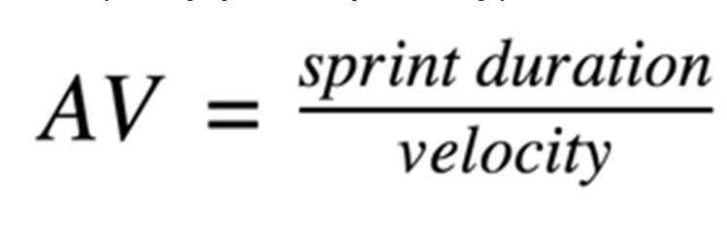

= 20/6 =3.33

# Burndown Chart:

A burn down chart is a graphical representation of work left to do versus time. It is often used in agile software development methodologies such as Scrum. However, burn down charts can be applied to any project containing measurable progress over time.

